When labeling and organizing cables in programming environments for biometrics, access points (APs), and other networking equipment, it is crucial to follow a structured approach to ensure clarity and maintenance. Here are some guidelines:

1. Labeling Cables for Biometric Systems and APs:

- Use clear, descriptive labels

:Ensure that each cable is labeled with a unique identifier that corresponds to its function, source, and destination.

- Color-coded labels:

Use color coding to distinguish between different types of cables (e.g., power cables, data cables, AP cables, biometric system cables, etc.).

- Print labels professionally:

Use printed labels rather than handwritten ones to avoid fading over time.

- Label both ends of the cable:

Ensure that both the source and destination ends of each cable are labeled for easy troubleshooting.

- Include relevant info:

Labels should include the following:

- Device ID (e.g., AP1, BioReader3)

- Port numbers (e.g., Switch Port 5 to Biometric Scanner)

- Cable type (e.g., Ethernet Cat6, USB, Fiber Optic)

- Installation date (optional)

2. Organizing Cables in Racks for Biometric and AP Systems:

- Use cable management systems:

Utilize cable trays, ties, and management arms to keep cables tidy and separated by function.

- Plan layout in advance:

Map out the rack and plan where each device (APs, biometric systems, servers, etc.) will be connected to avoid cable congestion.

- Bundle similar cables together:

Group cables by category, such as network cables, power cables, etc., and use Velcro ties instead of zip ties for easy adjustments.

- Leave slack where needed:

Ensure some slack in cables for flexibility and future maintenance but avoid excessive slack, which can cause tangling.

- Separate power and data cables:

Keep power cables separate from data cables to reduce electrical interference.

- Document your setup:

Maintain a cable map or diagram for future reference, indicating what each cable connects to and where it is routed

**HERE IS MAINTAINANCE TALKING PLACE**

. 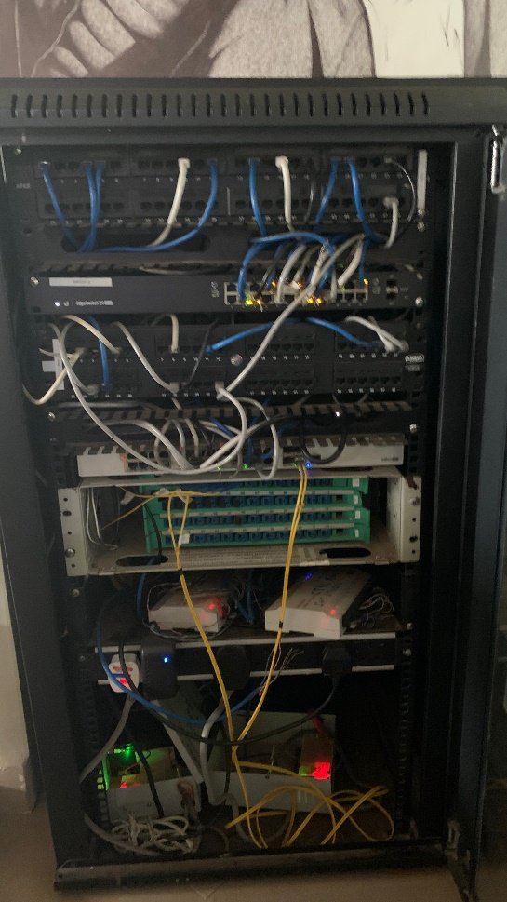

By following these steps, you ensure that the cables are easy to manage and troubleshoot, increasing the overall efficiency of the system.